Dated 24-03-2024

Assignment for Module 2: EC2 and EFS

Tasks To Be Performed:

1. Create an EFS and connect it to 3 different EC2 instances. Make sure that

all instances have different operating systems. For instance, Ubuntu, Red

Hat Linux and Amazon Linux 2.

Go to AWS Console and Select the EC2 Service

Create Ubuntu EC2 -EFS Instance

Click launch instance

Instance created

Now Go to EFS Service and create the EFS .

Click on create

EFS created

Click on Manage

Remove old security group and add the EC2 instance security group and save

Below is the EC2 instance security group

Connect EC2 Instance

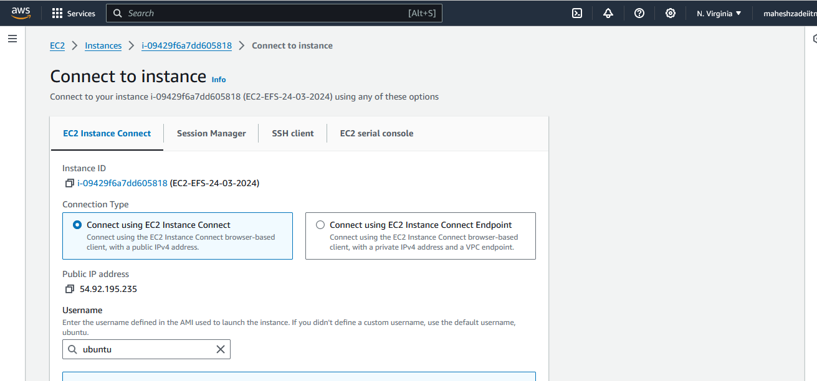

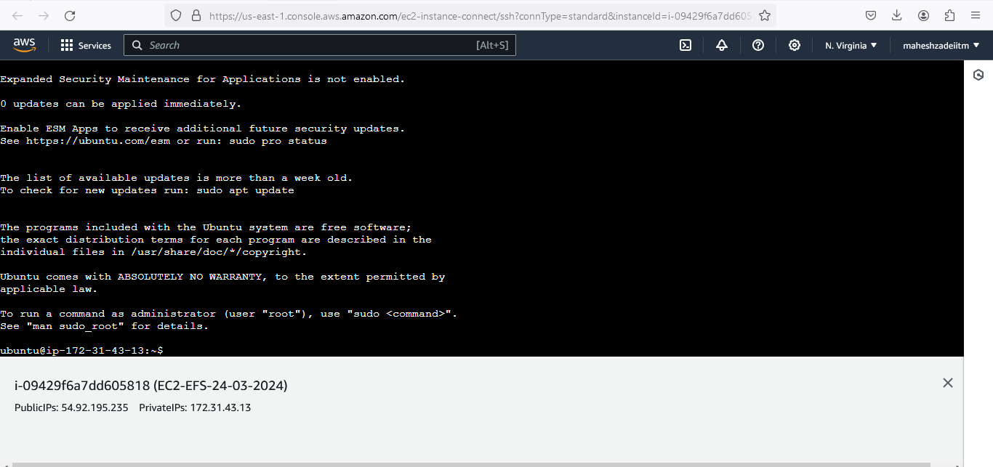

Update ubuntu by command

Sudo apt-get update

We need to connect to service we need to install NFS common.

Now go to NFS

Cli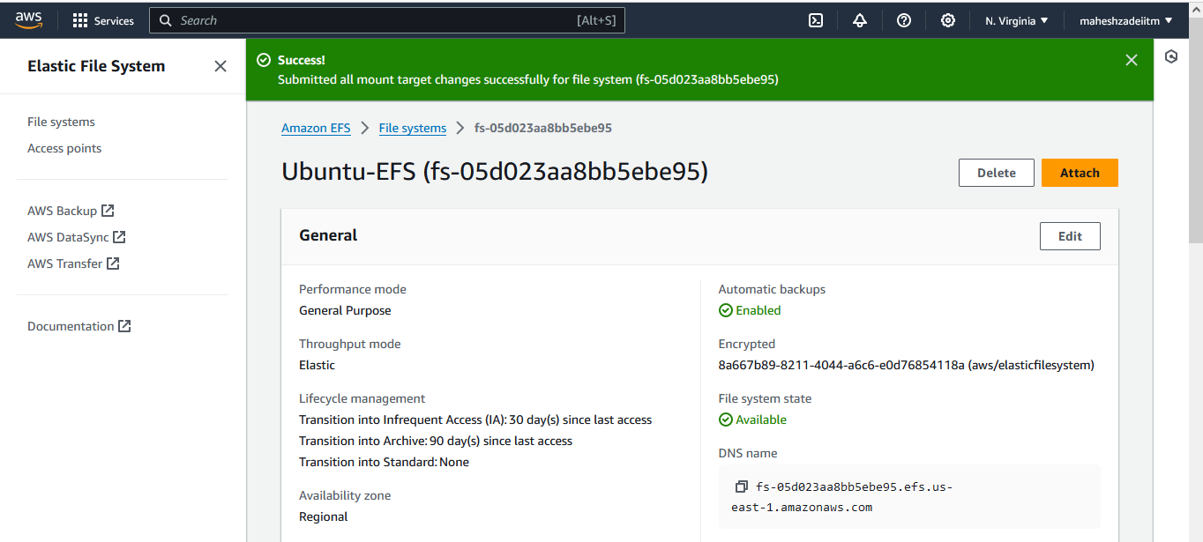

Click on attach

We are getting two options

Go to EC2 ubuntu instance

Make the efs directory

Check with ls command

Go to EFS

Copy nfs client

sudo mount -t nfs4 -o nfsvers=4.1,rsize=1048576,wsize=1048576,hard,timeo=600,retrans=2,noresvport fs-05d023aa8bb5ebe95.efs.us-east-1.amazonaws.com:/ efs

paste in EC2 instacne

